

[PPJP-48] Writing numbers in the full name field Created: 23/Aug/24 Updated: 23/Aug/24
Status: | To Do
Project: | Paws Paradise-Jira project

Type: | Bug | Priority: | Medium
Reporter: | Tomer Darmon | Assignee: | Unassigned
Environment: | Google Chrome  Version 124.0.6367.202 (Official version) (64 bit)  Microsoft Edge  Version 124.0.2478.97 (Official build) (64-bit)

Attachments: | 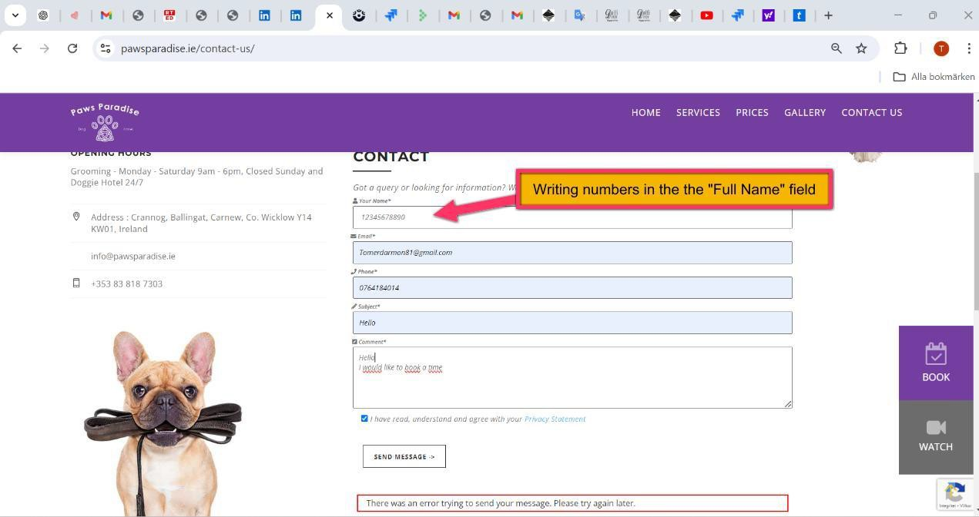
Severity1: | S3-Major

Description
Steps to Reproduce :
- Enter the website: https://www.pawsparadise.ie/contact-us/
- Scroll down to the "Your Name" field
- write in the "You Name" numbers: 12345678890
- Fill in the form and submit the form
Actual Result :
I don´t get any notification error regarding the specific area, only a general message that the site can’t go forward but not because of the bug i created
Expected Result :
The application should either prevent the user from entering numbers into the "Full Name" field or display an error message indicating that numbers are not allowed

67

